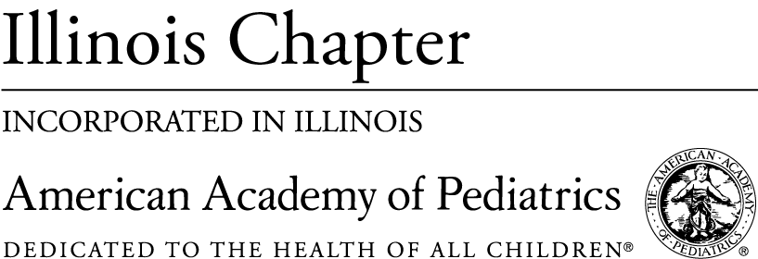
October 26th, 2020

Dear Illinois Department of Public Health Vaccines for Children Provider,

It is currently influenza season and it is more important than ever to get your patients vaccinated. It is especially important due to the COVID-19 epidemic. In collaboration with the Illinois Department of Public Health (IDPH), the Illinois Chapter, American Academy of Pediatrics (ICAAP) has enclosed a set of materials and resources that we think will be helpful in talking to patients and parents about the influenza vaccine. As you know, partners from around the state are working hard to significantly increase the uptake of the flu vaccine this year while also preparing the public to accept a COVID-19 vaccine when available.

We have included the following materials we hope will be useful to you in your practices:

- An ICAAP-developed poster in English and Spanish about the importance of well-child visits during COVID-19
- Influenza during COVID-19 from Immunization Action Coalition
- CDC Guide for Parents about Flu
  - English
  - Spanish
- CDC Guide on how to Talk to Children about the Flu
- Flu Fact Sheet from Families Fighting Flu
- Two Postcards from Families Fighting Flu
  - Communication 101
  - Warning Signs in Children about the Flu
- An ICAAP-developed Flu Innovation Summary

ICAAP has also launched a back-to-school campaign and a flu campaign with more resources, including strategies for how to communicate with patients and parents via social media channels, which can be found at http://bit.ly/ICAAPFlu

We are hopeful that these materials will provide you with the resources and knowledge to talk to parents and patients about the importance of the influenza vaccine

Best,
The Illinois Chapter, American Academy of Pediatrics

Funding for the flu campaign and mailer was made possible by funds received from the Office of Health Protection, through the Illinois Department of Public Health.

