First Steps: Improving Child Health and Housing
Model of Care for Pediatric Patients Facing
Housing Insecurity and Homelessness

©2021 Illinois Chapter, American Academy of Pediatrics

First Steps: Improving Child Health and Housing is Supported by a Grant from
the Otho S.A. Sprague Memorial Institute

The Illinois Chapter of the American Academy of Pediatrics (ICAAP) is a non-profit membership organization in Illinois dedicated to the health and well-being of children. ICAAP’s mission is to promote and advocate for optimal child, youth and family well-being, and access to quality health care while supporting our members.

Contributors

This model of care was produced by the Illinois Chapter, American Academy of Pediatrics. Contributors include Dr. Markeita Moore, Pediatrician, Evergreen Park Pediatrics; Vijay Subramaniam, DO, ICAAP Intern; Mary Elsner, Director, Health Equity Initiatives; Tim Herring, Coordinator, Health Equity Initiatives; Dr. Victor Thomas, Chief Medical Director, Christian Community Health Center; and Ed Stellon, Executive Director, Heartland Alliance Health.

Acknowledgements

ICAAP would like to express its gratitude to Dr. Markeita Moore, Chair of ICAAP’s First Steps Housing Education Workgroup, for her leadership, and representatives from the following housing and health care organizations in Chicago and across the state for contributing their expertise to this project. Their input is greatly appreciated.

- Illinois Association of Medicaid Health Plans
- Inspiration Corporation
- La Casa Norte
- Logan Square Health Center of Cook County
- Loyola University Medical Center
- Memorial Health System of Central Illinois
- New Moms
- Northwestern Children's Practice
- The Ounce of Prevention Fund
- Primo Center for Women and Children
- Rush University Medical Center
- Sinai Urban Heath Institute
- University of Chicago Comer Children’s Hospital
- WellCare Health Plans Inc.

- Access Community Health Network
- Advocate Medical Group
- AIDS Foundation of Chicago
- Ann and Robert H. Lurie Children's Hospital
- Catholic Charities
- Center for Housing and Health
- Chicago House
- Christian Community Health Center
- Cook County Health
- Corporation for Supportive Housing
- Esperanza Health Center
- Facing Forward to End Homelessness
- Friend Family Health Center
- Heartland Alliance Health
- Housing Opportunities for Women (HOW Inc)

For additional information, contact Mary Elsner, Director, Health Equity Initiatives, at melsner@illinoisaap.com.
A Model of Care is a vital quality improvement tool that allows a practice to meet the unique needs of its patient population and provides a foundation for promoting standard care management and coordination.

The Chronic Care Model identifies the essential elements of a health care system to provide high-quality care to a patient population with chronic diseases and utilizes a practical, evidence-based approach to create a proactive care team and informed patients.

The First Steps Model of Care for Pediatric Patients Facing Housing Insecurity has adapted the chronic care model to provide practice approaches to care and promote standard care management and coordination for families facing housing insecurity.

Part I - Organization of Care – The practice is structured to promote the delivery of high-quality and comprehensive care to pediatric patients and maintain continuity to prevent adverse child health risks associated with housing insecurity.

- Develop and implement a set of written policies focused on providing comprehensive, culturally sensitive care for patients facing housing insecurity, including:
  - Provide training during onboarding and periodically throughout the year for all staff, especially front desk staff, on housing insecurity and trauma responsive care
  - Consistently screen and document housing insecurity: utilize ICD-10 code for housing insecurity (see Addendum for further information on ICD-10 codes)
  - Display pamphlets of current resources in office waiting/exam rooms for families with housing insecurity
  - Collect and update contact information at each visit and collect alternative contacts – family, friends, shelter sites, etc.
  - Implement flexibility in scheduling: priority for scheduling; accommodate tardiness, and possible need for limited clinical services to allow for attending to basic needs, such as access to food and clothing; same-day visits for families with multiple children; and dedicated slots for walk-ins
  - Address factors that inhibit attending appointments, such as the option of telehealth visits to address simple medical needs
- Hire staff that reflects the demographics of the practice patient population with housing insecurity –including people with lived experience of homelessness, when possible.
- Assign designated staff to help families navigate the health care systems and address barriers to care, such as phones, internet, and language
Part II - Community Linkages – The connection developed between a practice and community resources such as shelter, local housing organization, school programs for housing insecure children, nutrition, and mental health programs.
- Develop and facilitate linkages for coordination and referrals with appropriate community resources, such as:
    - Transportation – bus, shuttle services, consider transportation when scheduling follow-up appointments
    - Students in Temporary Living Situations (STLS) Program – e.g., check eligibility for this federal/state public school program in your school district for preschool, elementary, and high school programs
    - Coordinated entry system / continuum of care / local housing organization
    - Emergency shelter
    - Local food pantries and soup kitchens
- Implement feedback loop with referral resource, if possible
- Facilitate connection between patient and community resource
- Post signs to alleviate fear of accessing care and to promote inclusivity, e.g., signage in different languages indicating “all are welcome here”
Part III - Care Delivery – Implement non-traditional health care delivery strategies to meet the needs of children and families experiencing housing insecurity.

- Utilize patient surveys to assure that the practice is welcoming and health care delivery meets patient needs
- Optimize acute care visits to best resolve patient concerns, provide comprehensive care when possible by treating each visit as the last visit, and consider the following:

- Same day labs if possible
- Updated immunizations at every opportunity
- Prescriptions – assess whether patient has refrigerator, provide discount prescription cards, consider stocking common medications in clinic per state regulations
- Address factors that inhibit attending appointments
- Maintain empathy, avoid assumptions, and offer non-judgmental support during the visit to avoid creating feelings of traditional institutional judgement
- Demonstrate cultural sensitivity when establishing communication with patient and create a bond of trust with the child and family
- Understand current housing situation and then partner with patient to develop treatment plan that decreases barriers to treatment, compliance, and follow-up posed by homelessness, e.g., lack of transportation, phone/internet, electricity, bathroom and kitchen facilities, and privacy

- Identify underlying causes of homelessness and help facilitate connection to appropriate resources

Part IV - Family/Child Management Support – Provision of effective support to children and families to cope with the challenges of housing insecurity.
- Identification of family goals and facilitation of connection to resources that meet immediate family needs, including:
- Enrollment of children in Medicaid and other benefit programs
  - Programs that address trauma and support resilience
  - Free or low-cost legal services
  - Free resources such as cell phones, furniture, diapers
  - Housing referral resources, e.g., homelessness emergency response system, homelessness prevention funds, rental assistance, housing authority waiting list (see Addendum for physician housing referral tool)
  - Daycare and schools, such as Early Head Start, Head Start, and Students in Temporary Living Situations (STLS) programs for children with housing insecurity
  - Financial and economic assistance programs, including expedited SSI disability
  - Prescription mailing programs/ Discount prescription cards
  - Employment opportunities and public benefits
  - Parenting programs – such as Triple P, The Incredible Years
  - Early Intervention Programs to address developmental delays
- Review and share information about resources with families
Part V - Best Practices and Clinical Guidelines – Follow guidelines, provide up-to-date resources, and monitor for health conditions associated with housing insecurity.

- Complete ICAAP’s Primary Care Primer on Housing Insecurity in Children and other continuing medical education focused on providing care to children with housing insecurity: https://illinoisaap.org/first-steps/
- Implement continuing medical education for trauma responsive care; access the AAP Trauma Toolbox for Primary Care Physicians: https://www.aap.org/traumaguide
- Use recommended housing screening questions that yield more accurate information about the patient’s underlying housing situation (see Addendum for sample screening tools)
- Screen for specific issues associated with housing insecurity in physiologic, mental health, and social realms, including screening for developmental delays
- Become familiar with management of conditions, infections, such as TB, and chronic diseases for this patient population
- Refer children and families to social, legal, financial, and housing supports, including crisis resources, homeless prevention funds, rapid rehousing, and permanent supportive housing
- Understand barriers to communication and follow-up, such as fear, moving from place to place, competing basic needs, such as food and clothing, shelter restrictions, and lack of experience with prior continuity of care or the health system in general. Find alternative means of staying in contact with a patient through family / friends / clergy / shelter
- Prioritize patient and family immediate needs and concerns
- Address disconnection with patient by asking address and phone information at every visit; essential contact information for person who will always know how to locate patient; a secondary contact, such as case manager, school or mental health provider; text or email only non-HIPAA information; a mailing address where patient can always retrieve mail
- Alert specialists to patients who are housing insecure so that their schedulers are encouraged to be flexible
Part VI - Clinical information systems – The system is designed to collect and store available clinical information important to the health care delivery process.
- Implement a diagnostic code for documentation of housing insecurity and utilize code to track patients
- Create a query for the practice’s housing insecure patient population to enhance management and outreach
- Provide data on documentation of screening and referrals to monitor practice and individual physician performance
- Obtain patient’s past medical records; check for gaps in vaccine records
- Create a template to support the clinical encounter for children with housing insecurity
- Develop a method for identifying patients for a warm handoff to staff who can provide patient support

Addendum

ICD-10 Code Definitions

Z59.0 – Homeless or Person lacking permanent or reliable shelter, variously due to poverty, lack of affordable housing, mental illness, substance abuse, juvenile alienation, or other factors
Z59.1 – Inadequate housing, restriction of space, and traveling between friends and family due to inadequate housing

Physician Housing Referral Tool
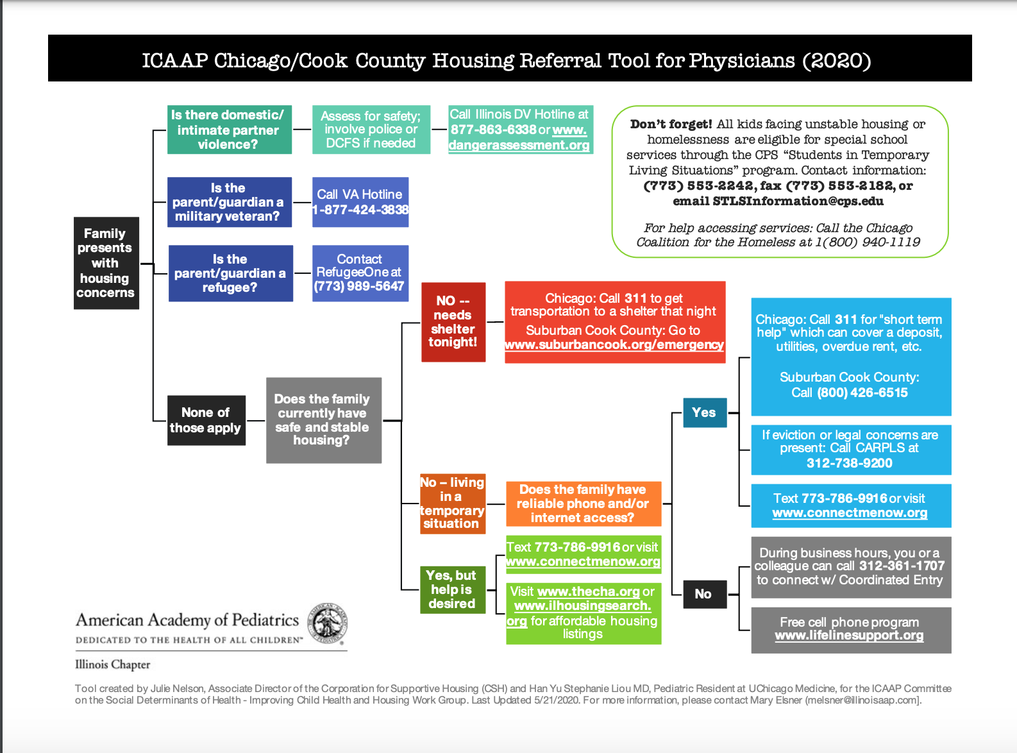

Heartland Alliance Health and Housing Screening Tool*

Housing Status: “Which of these best describes your living situation?”

- Own or lease a house or apartment
- Apartment with Case Management services (Other)
- Shelter (Shelter)
- Treatment Program, Hotel, SRO (Transitional)
- Stay w/Friends, Family (Doubling Up)
- Street, Park, Car, Train (Street)

Living Situation Question Flow Guide

Let’s talk about your living situation so we can ensure we are providing you the services that meet your needs.

Do you live in an apartment or house?
If yes to House, follow up with:
- Do you own your place or is your name on the lease?
- If yes, do not select any category and STOP
- If no, confirm they live with family or friends, select: Doubled Up
If yes to Apartment, follow up with:
- Is your name on the lease?
- If no, confirm they live with family or friends, select: Doubled Up
- If yes, their name is on the lease, follow-up with:
- Do you receive case management support with your apartment?
- If yes, select: Other (Permanent Supportive Housing)
- If no, do not select a category and STOP

If no, do you live in a hotel/motel, Single Room Occupancy (SRO), or a Treatment Facility?
If yes, select: Transitional

If no, do you live in a shelter?
If yes, select: Shelter

If no, do you live on the streets (outside, in a car, the park, on the train or in a place that is not meant for people to live)?
If yes, select: Street

*This tool has not been validated. However, it is utilized by Heartland Alliance Health, a Federally Qualified Health Center, which has a special designation for providing care to patients with housing insecurity.

Sandel et al. Housing Screening Tool

Sandel M, Sheward R, Ettinger de Cuba S, et al. Unstable Housing and Caregiver and Child Health in Renter Families. Pediatrics. 2018;141(2):e20172199
Screening questions:
- “During the last 12 months, was there a time when you were not able to pay the mortgage or rent on time?”
- “In the past 12 months, how many places has the child lived?”
- “What type of housing does the child live in?”
- Current Homelessness: positive screen if currently living in a shelter, motel, temporary or
transitional living situation, scattered site housing, or no steady place to sleep at night.
4. “Since the child was born, has she or he ever been homeless or lived in a shelter?”
- History of Homelessness: positive screen if patient indicates having lived in a shelter,
motel, temporary or transitional living situation, scattered site housing, or no steady place
to sleep at night.

Centers for Medicare & Medicaid Services 2017 Housing Screening Questions

What is your housing situation today?
  - I do not have housing (I am staying with others, in a hotel, in a shelter, living outside on the street,
on a beach, in a car, abandoned building, bus or train station, or in a park)
  - I have housing today, but I am worried about losing housing in the future
  - I have housing

PRAPARE- National Association of Community Health Centers
- What is your housing situation today?
  - I have housing
  - I do not have housing (staying with others, in a hotel, in a shelter, living outside on the street, on a beach, in a car, or in a park)
  - I choose not to answer this question
- Are you worried about losing your housing?
  - Yes
  - No
  - I choose not to answer this question
- What address do you live at? (include street and zip code)
  - Street
  - City, State, Zip code

