First Steps: Improving Child Health and Housing

©2021 Illinois Chapter, American Academy of Pediatrics

First Steps: Improving Child Health and Housing is Supported by a Grant from
the Otho S.A. Sprague Memorial Institute

Assessment of Welcoming Practices
for Pediatric Patients
Facing Housing Insecurity and Homelessness

The Illinois Chapter of the American Academy of Pediatrics (ICAAP) is a non-profit membership organization in Illinois dedicated to the health and well-being of children. ICAAP’s mission is to promote and advocate for optimal child, youth and family well-being, and access to quality health care while supporting our members.

Contributors

This model of care was produced by the Illinois Chapter, American Academy of Pediatrics (ICAAP). Contributors include Dr. Markeita Moore, Pediatrician, Evergreen Park Pediatrics; Vijay Subramaniam, DO, ICAAP Intern; Dr. Victor Thomas, Chief Medical Director, Christian Community Health Center, Ed Stellon, Executive Director, Heartland Alliance Health; Mary Elsner, JD, Director, ICAAP Health Equity Initiatives; and Tim Herring, Coordinator, Health Equity Initiatives.

Acknowledgements

ICAAP would like to express its gratitude to Dr. Markeita Moore, Chair of ICAAP’s First Steps Housing Education Workgroup, for her leadership, and representatives from the following housing and health care organizations in Chicago and across the state for contributing their expertise to this project. Their input is greatly appreciated.
- Illinois Association of Medicaid Health Plans
- Inspiration Corporation
- La Casa Norte
- Logan Square Health Center of Cook County
- Loyola University Medical Center
- Memorial Health System of Central Illinois
- New Moms
- Northwestern Children's Practice
- The Ounce of Prevention Fund
- Primo Center for Women and Children
- Rush University Medical Center
- Sinai Urban Heath Institute
- University of Chicago Comer Children’s Hospital
- WellCare Health Plans Inc.

- Access Community Health Network
- Advocate Medical Group
- AIDS Foundation of Chicago
- Ann and Robert H. Lurie Children's Hospital
- Catholic Charities
- Center for Housing and Health
- Chicago House
- Christian Community Health Center
- Cook County Health
- Corporation for Supportive Housing
- Esperanza Health Center
- Facing Forward to End Homelessness
- Friend Family Health Center
- Heartland Alliance Health
- Housing Opportunities for Women (HOW Inc)

For additional information, contact Mary Elsner, Director, Health Equity Initiatives, at melsner@illinoisaap.com.
The First Steps Model of Care for Pediatric Patients Facing Housing Insecurity has adapted the chronic care model to provide practice approaches to care and promote standard care management and coordination for families facing housing insecurity. This assessment is a quality improvement tool designed to help practices implement the First Steps Model of Care.

Instructions: To qualify as a practice that meets the needs of families experiencing housing insecurity, you must meet all 6 requirements. The allotted points are provided to the right of each section and should be calculated on page 8 for a final score.

The addendum provided at the end of checklist provides ICD-10 codes, screening tools, and a sample physician housing referral tool, ICAAP Chicago/Cook County Housing Referral Tool for Physicians, referenced in the checklist.

Part I - Organization of Care – The practice is structured to promote the delivery of high-quality and comprehensive care to pediatric patients and maintain continuity to prevent adverse child health risks associated with housing insecurity. (Check off this box if you have completed parts A-C below. Record the total number of points for this section on the right side. The bonus point can be used to improve your overall practice score.)
Total pts: / 9 pts
A. Develop and implement a set of written policies focused on providing comprehensive, culturally sensitive care for patients facing housing insecurity, including:
- Training during onboarding and periodically throughout the year for all staff, especially front desk staff, on housing insecurity and trauma responsive care
/1 pt
- Consistent screening and documentation of housing insecurity: appropriate use of coding for housing insecurity (see addendum)
/1 pt
- Collect and update contact information at each visit and collect alternative contacts – family, friends, shelter sites, etc.
/1 pt
- Flexibility in scheduling: priority scheduling; accommodate tardiness, and possible need for limited clinical services to allow for attending to basic needs, such as access to food, clothing; same-day visits for families with multiple children; and dedicated slots for walk-ins
/1 pt

- Address factors that prevent patient from attending appointments, such as the option of telehealth visits to address simple medical needs
/1 pt

Bonus point (Strongly Recommended but not required)

- Office displays waiting room/exam room pamphlets with current resources for families with housing insecurity
/1 pt

B. Recruit staff with an emphasis on experience in housing insecurity.
1. List open staff positions with organizations in the homeless sector (Corporation for Supportive Housing, local continuum of care)
/1 pt
2. Include lived experience or professional work with housing insecure populations in job description
/1 pt
3. Weigh job candidates prior housing experience in hiring decision
/1 pt

C. Assign designated staff to help families navigate the healthcare system and address barriers to care, such as phones, internet, and language
/1 pt

Part II - Community Linkages – The practice develops a connection with community resources such as school programs for housing insecure children, nutrition, and mental health programs. (Check off this box if you have completed part A below. Record the total number of points for this section on the right side. The bonus points can be used to improve your overall practice score.)
Total pts: / 3 pts
A. Develop and facilitate linkages for coordination and referrals with appropriate community resources, such as: (obtain a total of 3 pts to complete part A by complying with 3 of 5 labeled 1-5 below):
1. Transportation – bus, shuttle services, consider transportation when scheduling follow-up appointments
/1 pt
2. Students in Temporary Living Situations/ McKinney Vento (Public School Program)
/1 pt

3. Local housing organization/ continuum of care/ coordinated entry system
/1 pt
4. Local food pantries and soup kitchens
/1 pt
5. Patient referral to emergency shelter
/1 pt

Part III - Care Delivery – Implement non-traditional health care delivery strategies to meet the needs of children and families experiencing housing insecurity. (Check off this box if you have completed parts A-B below. Record the total number of points for this section on the right side. The bonus points can be used to improve your overall practice score.)
Total pts: / 3 pts
- Optimize acute care visits to best resolve patient concerns, provide comprehensive care when possible by treating each visit as the last visit, and consider the following (obtain a total of 2 pts to complete part A by complying with 2 of 4 labeled 1-4 below):

1. Same day labs if possible
/1 pt
2. Update immunizations at every opportunity
/1 pt
3. Prescriptions – assess whether patient has refrigerator, provide Rx discount cards, consider stocking common medications and utilizing free drug samples in clinic per state regulations
/1 pt
4. Address factors that inhibit attending appointments
/1 pt
- Maintain empathy, avoid assumptions, and offer non-judgmental support during the visit to avoid creating feelings of traditional institutional judgement (do debriefing for all staff)

/1 pt

Part IV - Family/Child Management Support – Provision of effective support to children and families to cope with the challenges of housing insecurity. (Check off this box if you have completed part A below. Record the total number of points for this section on the right side. The bonus points can be used to improve your overall practice score.)
Total pts: / 5 pts
- Identify family goals and facilitation of connection to resources that meet immediate family needs. (Obtain a total of 5 pts to complete part A by providing linkages to #1-3 and at least 2 more of other items listed below. The bonus points can be used to improve your overall practice score.)
1. Child enrollment in Medicaid and/or provide information regarding other benefit programs
/1 pt
2. Housing and food insecurity resources
/1 pt
3. Early Intervention Programs (eligibility for all children experiencing homelessness)
/1 pt
4. Free or low-cost legal services
/1 pt
5. Free resources such as cell phones, furniture, diapers
/1 pt
6. Programs that address trauma and support resilience
/1 pt
7. Daycare and school linkages, such as Early Head Start, Head Start, and Students in Temporary Living Situations (STLS) programs for children with housing insecurity

/1 pt
8. Financial and economic assistance programs, including expedited SSI disability
/1 pt
9. Prescription mailing programs/ Discount prescription cards
/1 pt
10. Employment assistance programs and public benefits
/1 pt
11. Parenting programs /1 pt
Part V - Best Practices and Clinical Guidelines – Follow guidelines, provide up-to-date resources, and monitor health conditions associated with housing insecurity. (Check off this box if you have completed parts A-E below. Record the total number of points for this section on the right side.)
Total pts: / 5 pts
- Complete ICAAP’s Primary Care Primer on Housing Insecurity in Children or other continuing medical education focused on providing care to children with housing insecurity, which incorporates screening for specific issues associated with housing insecurity, such as developmental delays and common infections, in physiologic, mental health, and social realms
/1 pt
- Complete continuing medical education for trauma responsive care or equivalent
/1 pt
- Use recommended housing screening questions that yield more accurate information about the patient’s underlying housing situation (see sample screening tools in addendum)
/1 pt
- Avoid losing communication with patient/family by asking address and phone information at every visit; essential contact information for person who will always know how to locate patient; address where the patient can always retrieve mail
/1 pt
- Alert specialists to patients who are housing insecure so that their schedulers are encouraged to be flexible
/1 pt

Part VI - Clinical Information Systems – The system is designed to collect and store available clinical information important to the healthcare delivery process. (Check off this box if you have completed parts A-C below. Record the total number of points for this section on the right side.)
Total pts: / 3 pts
- Implement a consistent practice-wide diagnostic code for documentation of housing insecurity and utilize code to track patients. Consider using ICD-10 codes: Z59.0 homelessness-literal homelessness, Z59.1 Inadequate housing-traveling between friends and family (See Addendum for further information on ICD-10 codes)
/1 pt
- Create a query for the practice’s housing insecure patient population to enhance management and outreach
/1 pt
- Develop a workflow for a warm handoff of patients identified as housing insecure to staff who has access to resources to address their basic needs (food, shelter-text 311, phone)
/1 pt

Quality Improvement Score

Section | Minimum Number of Required Points | Actual Number of Points
Part I - Organization of Care | 9 pts
Part II - Community Linkages | 3 pts
Part III - Care Delivery | 3 pts
Part IV - Family/Child Management Support | 5 pts
Part V - Best Practices and Clinical Guidelines | 5 pts
Part VI - Clinical Information Systems | 3 pts
Total points | 28 pts

Level 1 10-19 pts – approaching the baseline for a welcoming practice
Level 2 20-27 pts – making progress towards a welcoming practice
Level 3 28 pts – meeting expectations for a welcoming practice
Level 4 > 28pts – exceeding expectations for a welcoming practice

Addendum

ICD-10 Code Definitions

Z59.0 – Homeless or Person lacking permanent or reliable shelter, variously due to poverty, lack of affordable housing, mental illness, substance abuse, juvenile alienation, or other factors
Z59.1 – Inadequate housing, restriction of space, and traveling between friends and family due to inadequate housing

Physician Housing Referral Tool
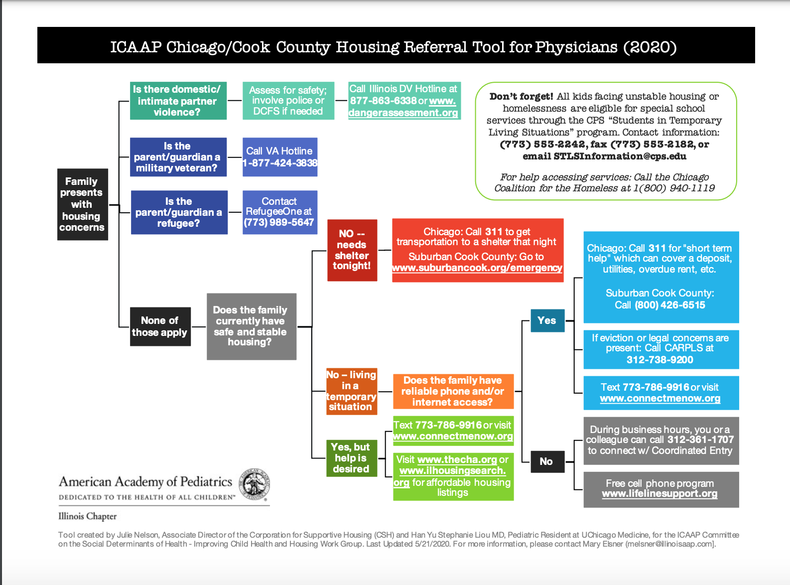

Heartland Alliance Health and Housing Screening Tool*

Housing Status: “Which of these best describes your living situation?”

- Own or lease a house or apartment
- Apartment with Case Management services (Other)
- Shelter (Shelter)
- Treatment Program, Hotel, SRO (Transitional)
- Stay w/Friends, Family (Doubling Up)
- Street, Park, Car, Train (Street)

Living Situation Question Flow Guide

Let’s talk about your living situation so we can ensure we are providing you the services that meet your needs.

Do you live in an apartment or house?
If yes to House, follow up with:
- Do you own your place or is your name on the lease?
- If yes, do not select any category and STOP
- If no, confirm they live with family or friends, select: Doubled Up
If yes to Apartment, follow up with:
- Is your name on the lease?
- If no, confirm they live with family or friends, select: Doubled Up
- If yes, their name is on the lease, follow-up with:
- Do you receive case management support with your apartment?
- If yes, select: Other (Permanent Supportive Housing)
- If no, do not select a category and STOP

If no, do you live in a hotel/motel, Single Room Occupancy (SRO), or a Treatment Facility?
If yes, select: Transitional

If no, do you live in a shelter?
If yes, select: Shelter

If no, do you live on the streets (outside, in a car, the park, on the train or in a place that is not meant for people to live)?
If yes, select: Street

*This tool has not been validated. However, it is utilized by Heartland Alliance Health, a Federally Qualified Health Center that has a special designation for providing care to patients with housing insecurity.

Sandel et al. Housing Screening Tool

Sandel M, Sheward R, Ettinger de Cuba S, et al. Unstable Housing and Caregiver and Child Health in Renter Families. Pediatrics. 2018;141(2):e20172199
Screening questions:
- “During the last 12 months, was there a time when you were not able to pay the mortgage or rent on time?”
- “In the past 12 months, how many places has the child lived?”
- “What type of housing does the child live in?”
- Current Homelessness: positive screen if currently living in a shelter, motel, temporary or
transitional living situation, scattered site housing, or no steady place to sleep at night.
4. “Since the child was born, has she or he ever been homeless or lived in a shelter?”
- History of Homelessness: positive screen if patient indicates having lived in a shelter,
motel, temporary or transitional living situation, scattered site housing, or no steady place
to sleep at night.

Centers for Medicare & Medicaid Services 2017 Housing Screening Questions

What is your housing situation today?
  - I do not have housing (I am staying with others, in a hotel, in a shelter, living outside on the street,
on a beach, in a car, abandoned building, bus or train station, or in a park)
  - I have housing today, but I am worried about losing housing in the future
  - I have housing

PRAPARE- National Association of Community Health Centers
- What is your housing situation today?
  - I have housing
  - I do not have housing (staying with others, in a hotel, in a shelter, living outside on the street, on a beach, in a car, or in a park)
  - I choose not to answer this question
- Are you worried about losing your housing?
  - Yes
  - No
  - I choose not to answer this question
- What address do you live at? (include street and zip code)
  - Street
  - City, State, Zip code

